ATTACHMENTS

Creation Of Spreadsheet:

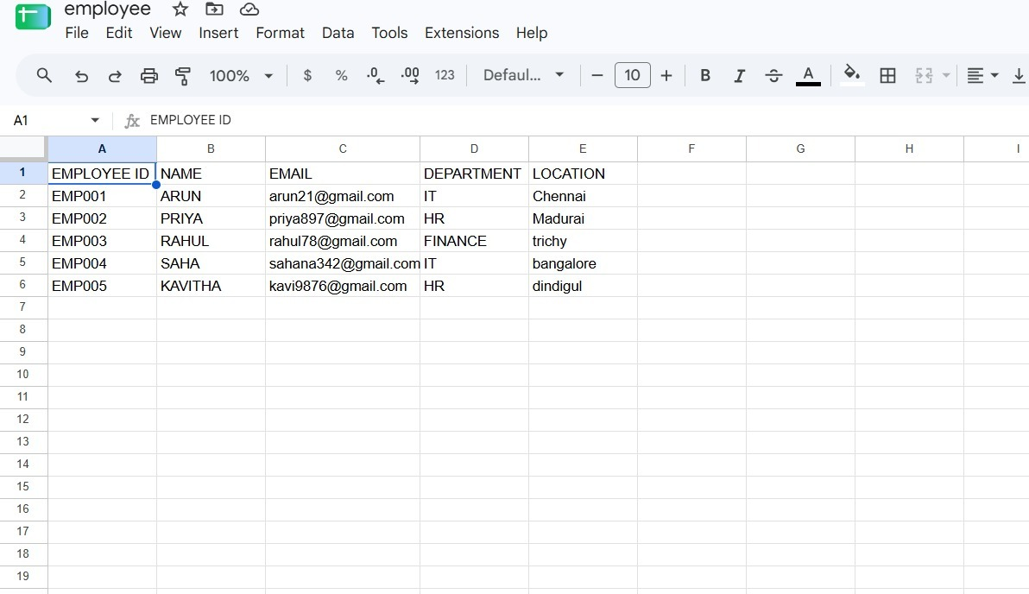

Creation of Tables:

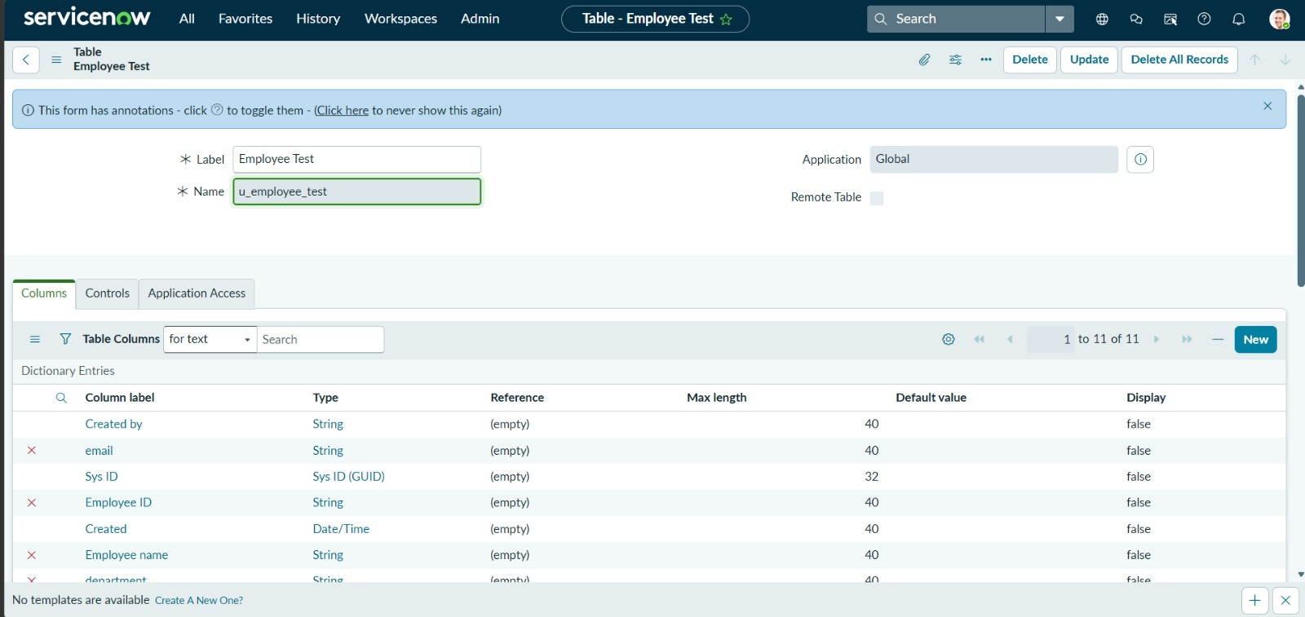
Verify that the newly created fields are displayed on the Employee Test form

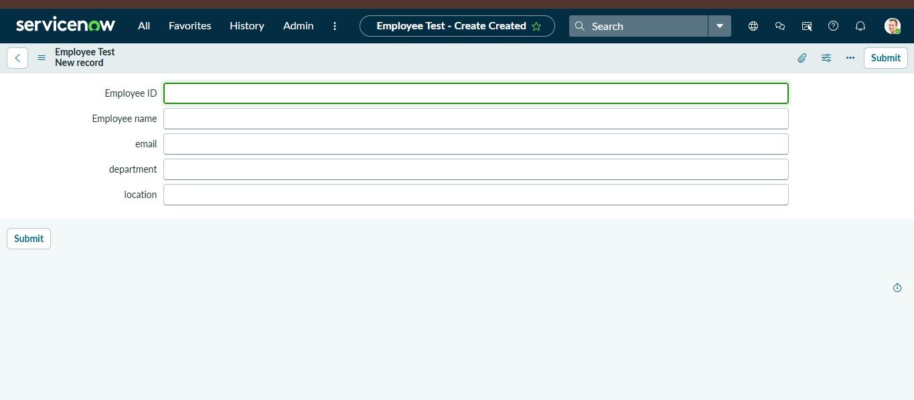

Create Importset Table:

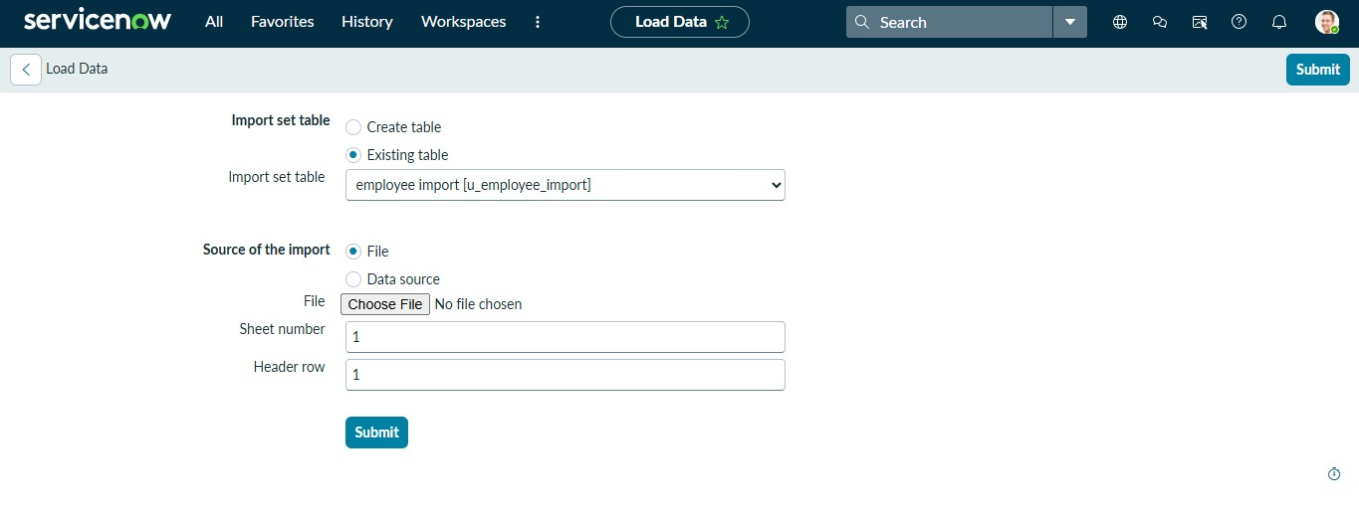

Once we click on Submit, we can see the success message as shown below.
Also we need to make sure to click on Create Transform Map.

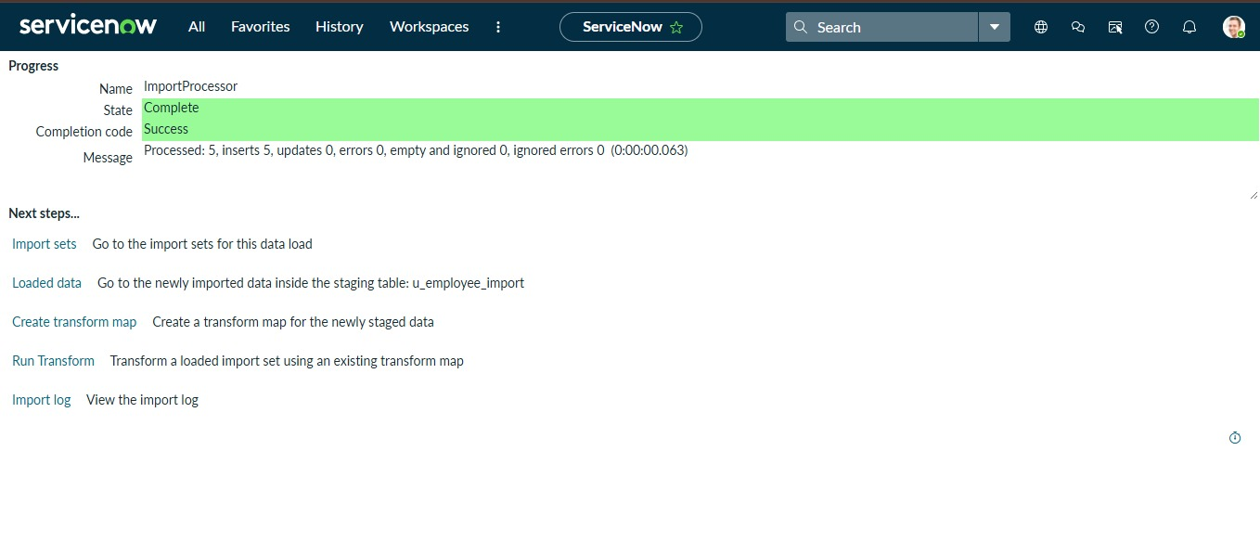

Create Transform Map:

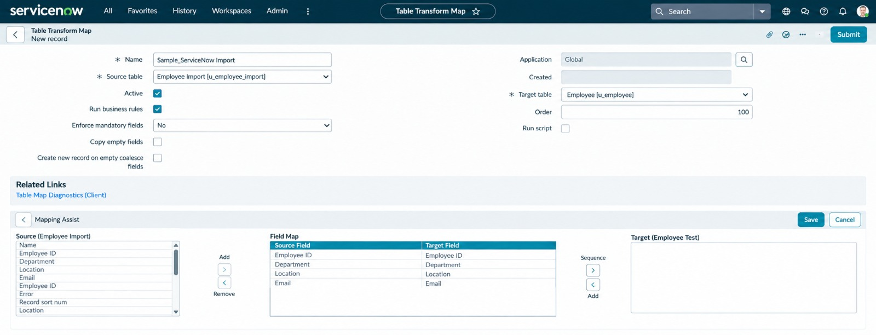

Now click on Transform as shown below

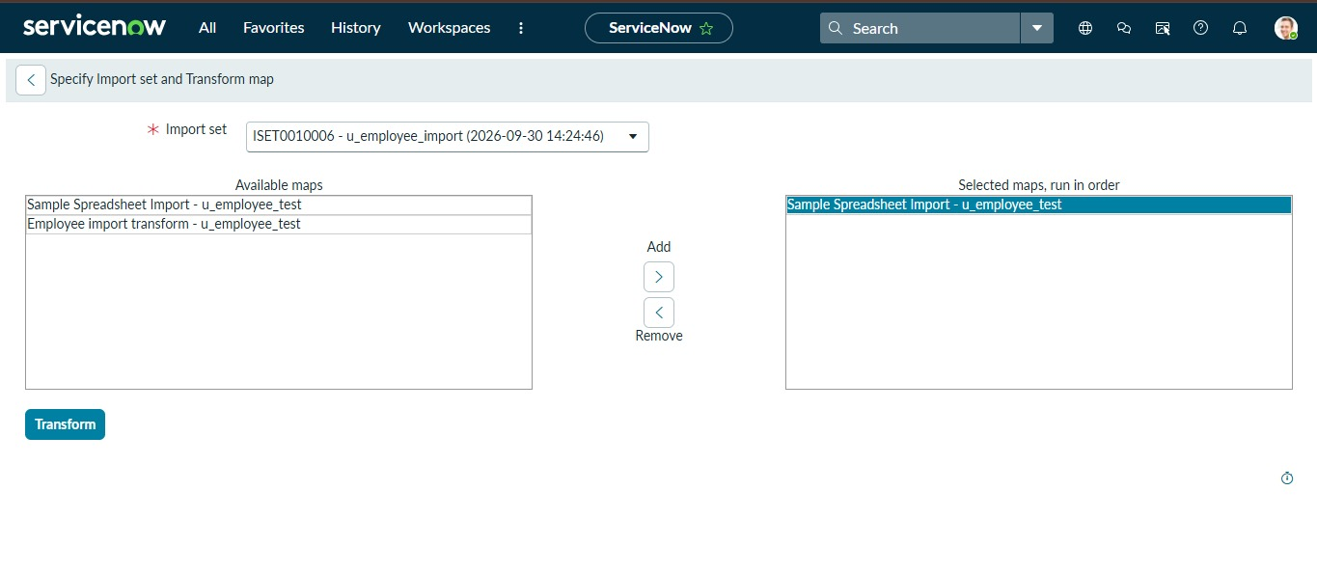
After clicking Transform, make sure you see the success message as shown below.
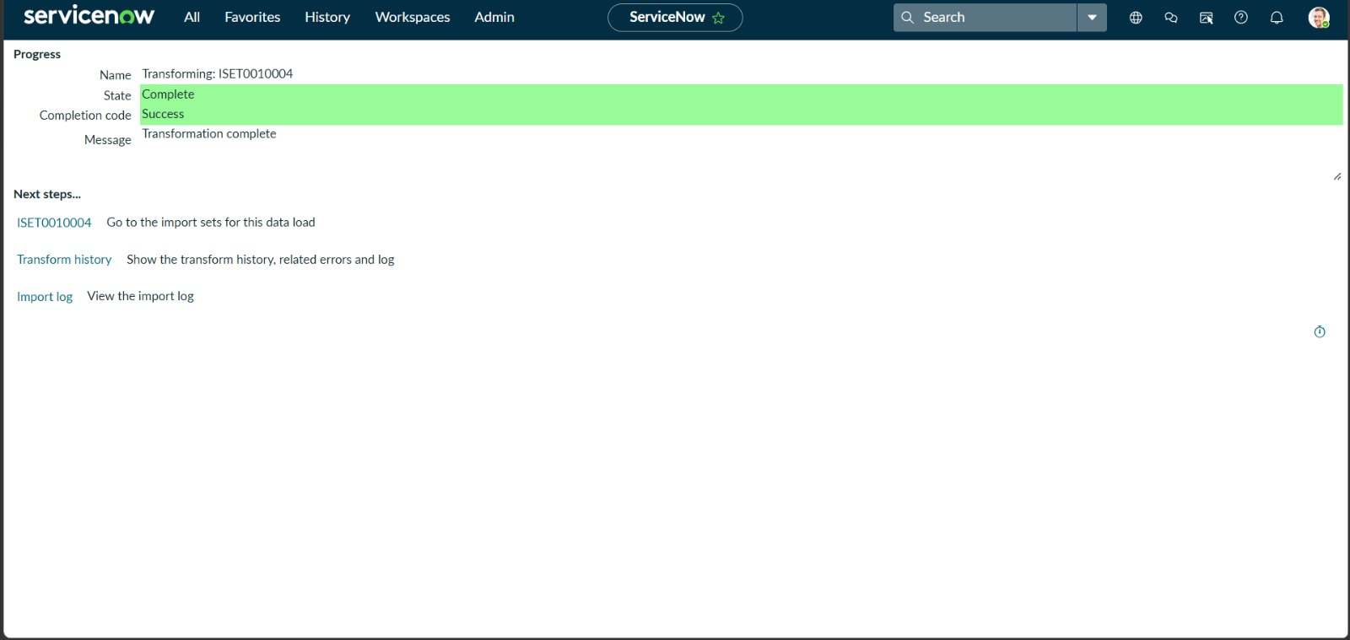

Transform Data & Validate:

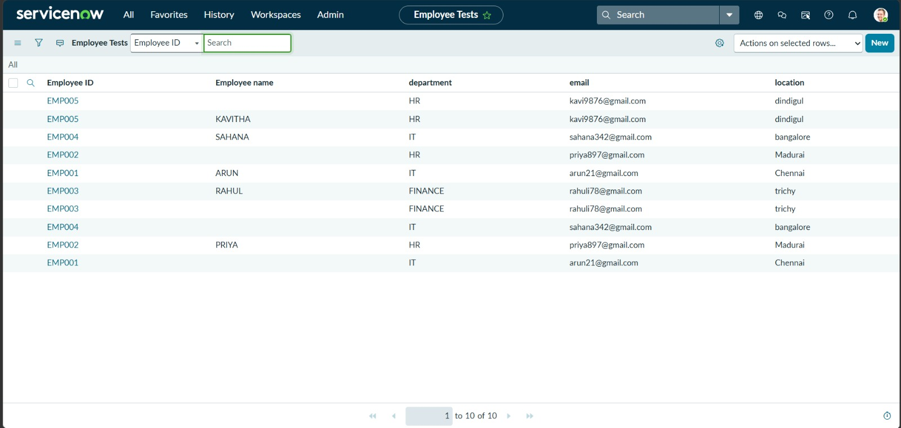

Enable Coalesce to Avoid Duplicate Records:

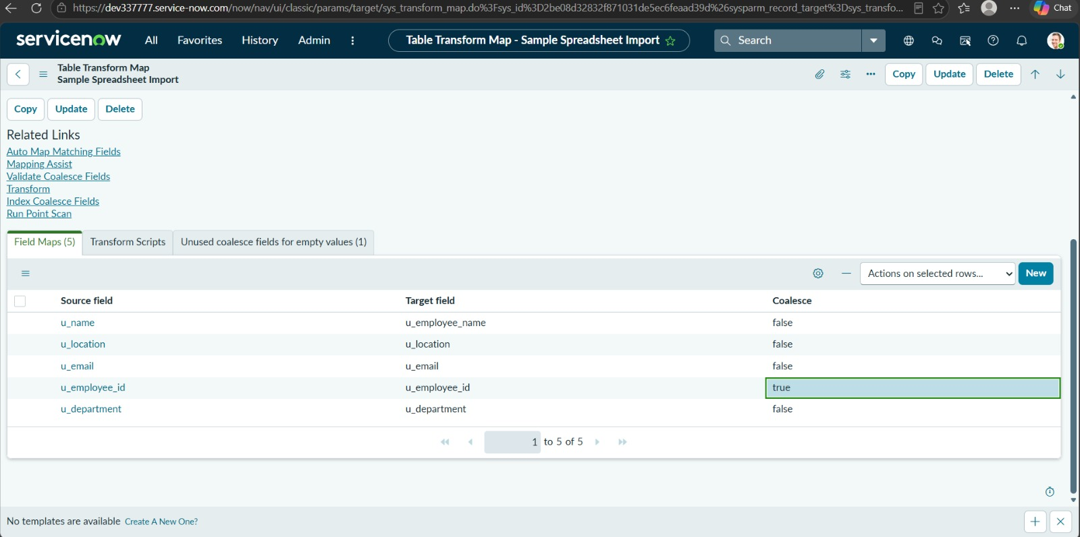

Inserting New Data In Excel Format:

Navigate to All menus.
Search for Load data Under System Import set Open Load Data.
Fill the detail and click a submit button

It appears as State Completed and Success.

Then Click the Transform button.

Now the State is completed and Success.

Again click on the Transform history then it shows the newly added data and its status of Inserted and Skipped values out the given data.
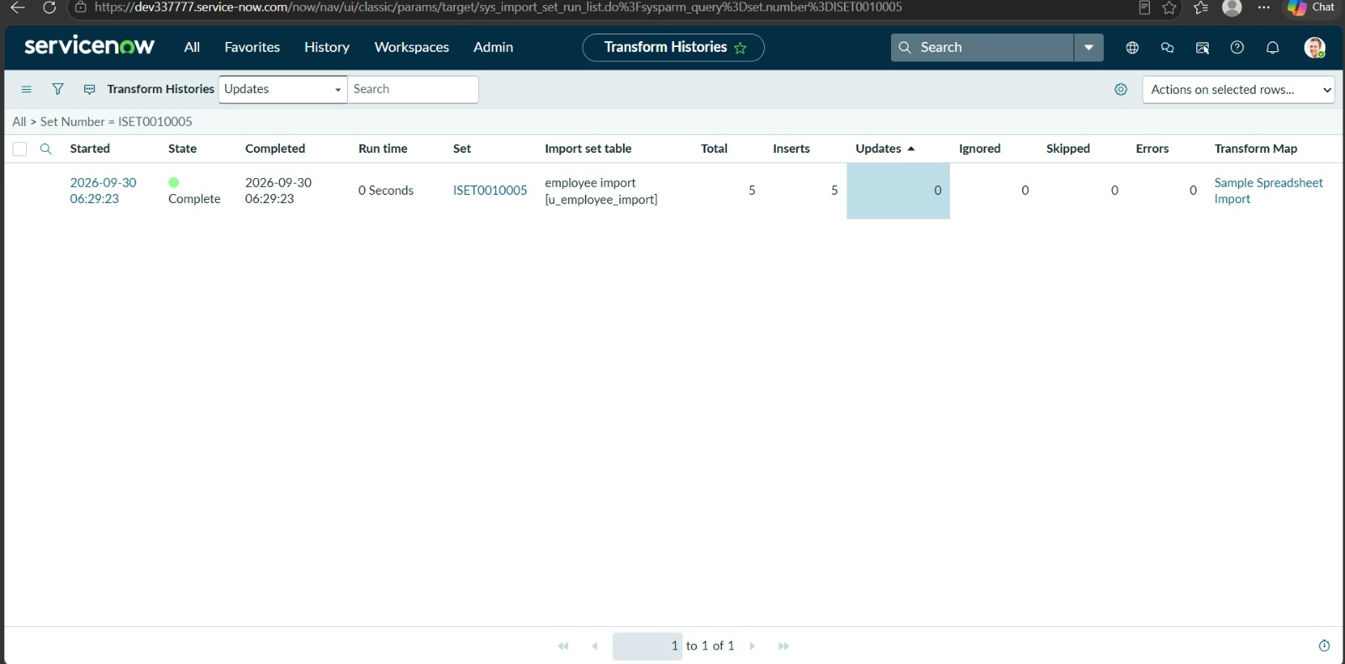

Report :
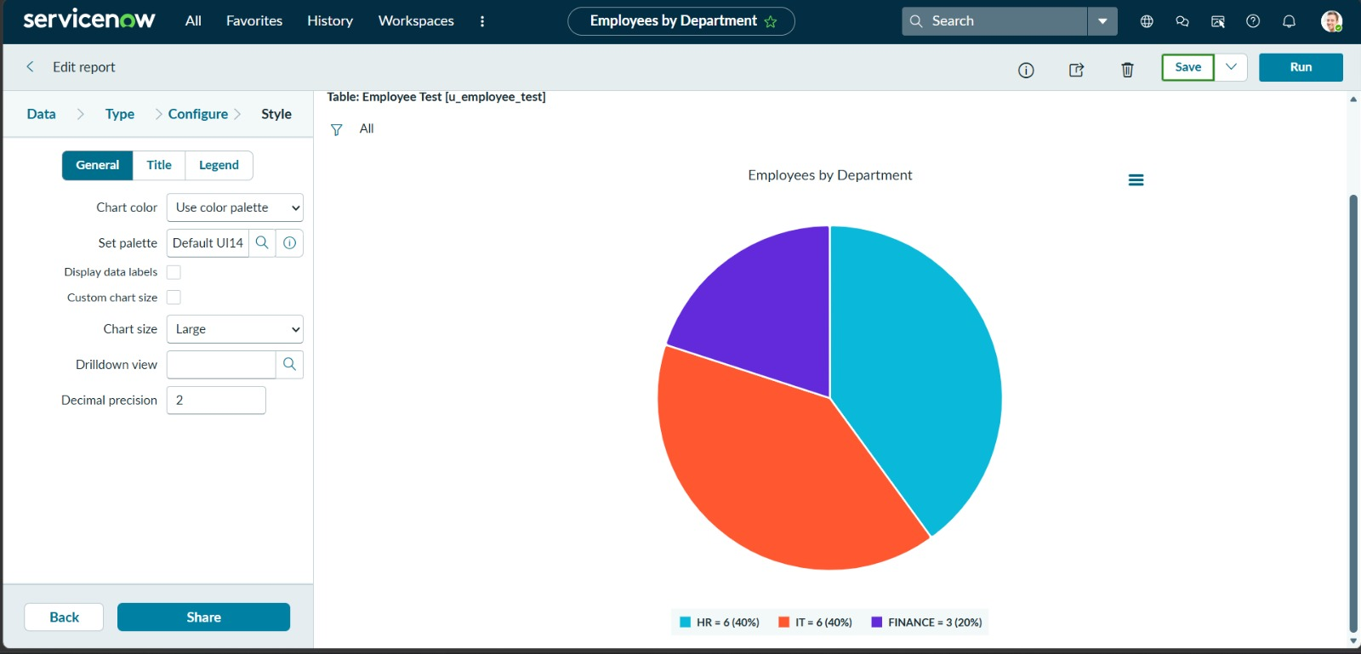

Adding Reports to Dashboard:

After Opening the ACL Search the pa_dashboards on Name Column
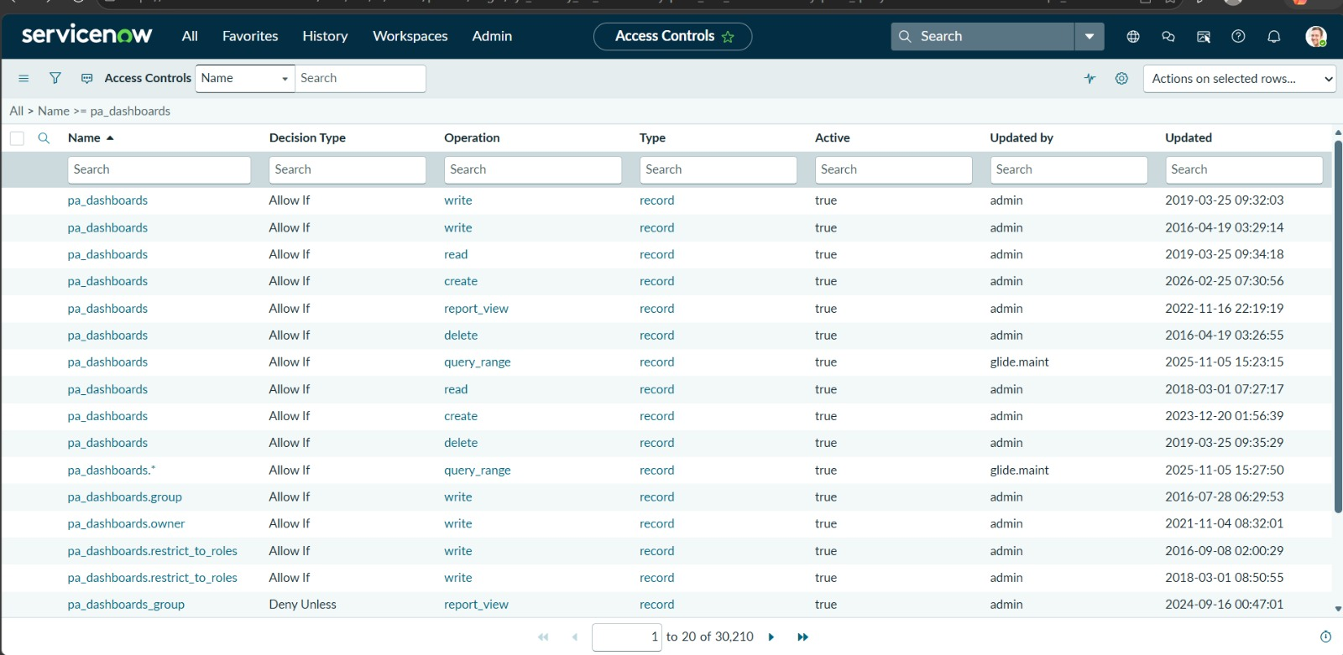
Here the three Reports are added successfully by varying Department , Location and List Report.

